Design and Implementation of Mobile Proxy
Case Study: Mobile Data Collection

Aris Prawisudatama
School of Electrical Engineering and Informatics
Institut Teknologi Bandung
Bandung, Indonesia
soedomoto@gmail.com
I Gusti Bagus Baskara Nugraha
School of Electrical Engineering and Informatics
Institut Teknologi Bandung
Bandung, Indonesia
baskara@stei.itb.ac.id

Abstract—Data collection using mobile device is something that is quite common recently. However, most of those applications are using static validation rules. The use of mobile proxy to duplicate rule and data is believed could improve the flexibility and implementation of the validation rule. Rule could be easily designed in modular basis, installed, updated, as well as deleted from application using OSGi framework. This paper is aimed to research about the design and implementation of mobile proxy that could be used to implement dynamic validation rule on SOA-based mobile device.
Keywords—proxy; mobile proxy; dynamic proxy; service oriented architecture; SOA; REST

Introduction
Data collection is one of the main tasks of statistical institution in the world, including BPS-Statistics Indonesia. Data collection process is conducted using various media, ranging from conventional method, such as paper questionnaire to the modern method using mobile device. Until now, most of data collection conducted by BPS-Statistics Indonesia are still using paper questionnaire. However, BPS started using mobile device for collecting data. The use of this technology aims to reduce non-sampling error, the error was caused by, one of them, the enumerator.
In data collection, the most important thing to be considered is the data quality. Data quality is measured using consistency and validation parameter. Data collection using paper questionnaire still rely on human’s carefulness and thoroughness in implementing the rule. Using mobile device has a benefit related to consistency and validation. Thus, generally, using mobile device could increase data quality.
The scenario that is commonly used in the implementation of mobile device application is to wrap it in a package including GUI and workflow. This scenario has a weakness, the workflows that are used are static and cannot be added, removed, or updated, except by updating the whole application.
Another scenario which is also commonly used is by adopting a Service-Oriented approach. Service oriented approach basically separated into two components: the service provider (server) and a service consumer (client). In Service-based approach, the workflow will be executed on the server, while the client access the workflow through a network. Service-based approach has been widely implemented, including implementation on mobile based applications. However, the implementation of service-based approach to the mobile device has several potential obstacles, mainly due to the availability of the Internet network, so mobile device that acts as a client cannot always connect to the server. No connection of mobile devices on the server can be categorized into three types [1]:
- Delay-based interruption: delays in message delivery because of problems that occur between the sender and receiver,
- Network outage: a condition where a node is disconnected from the other nodes. Cause outage network include: network failure, mobile devices moving between zones, laptops going to sleep, unplugged cables, or inadvertent closing of the application,
- Explicit departure: a condition in which the user explicitly logs out of the session or quits the application.
The proposed alternative scenario is to adopt a proxy approach. Proxy approach basically is to put a server between the service provider and the service consumer that will intercept the request from the client to the server. Proxy can act as a forward proxy in a condition connected to the network, or cache server in conditions not connected with the network. Illustration of proxy that will be designed can be seen in Fig. 1.

- Proxy Overview

This paper will examine how to design a proxy that can be used in a condition connected or disconnected, which is divided into five sections. Section 1 is the background of this research. While the second section will discuss the literature review and research related to the design of the proxy. Section 3 will discuss the proposed design, followed by a discussion in section 4. Finally section 5 concludes the paper with a summary and a discussion of future work.

Theoretical Background
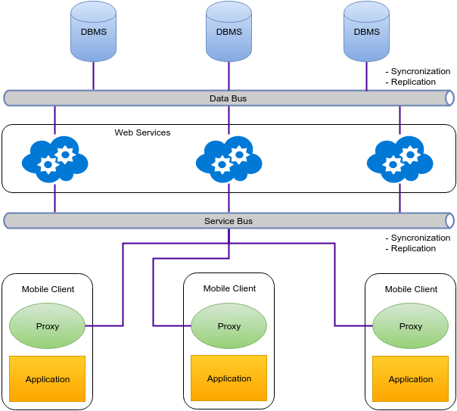
- Proxy Overview
In general, the proxy can be said as a placeholder for other entities [2]. Due to its capability to intercept communication source and target, it allows deferring the initialization of the target, redirecting the communication target to one or more entities, performing additional capabilities before/after communicating with the target, etc. [3].
Implementation of the proxy have been conducted with various purposes, e.g., for memory efficiency [2], remote communication [4], and concurrent data evaluation/processing (e.g. for future object) [5]. Proxies have also been used in component-based middleware such as EJB [6], to provide various enterprise-level capabilities. Furthermore, proxies have also been widely adopted in contemporary work on application adaptation [7] [8] [9] [10] [11] [12], since they allow certain components of an application to dynamically reconfigure themselves (e.g. changing its behavior) transparently, i.e. without the awareness of the rest of the components in the application. While on the mobile device, the proxy is used to bridge the wired-wireless gap, and make all mobility, connectivity and context-dependent issues transparent to the application developer [9].
To support the mobility of a mobile device, the proxy must also be portable and dynamic. Rubinsztejn et al make the architectural design of the proxy in the form of middleware, which consists of both server and client API [9] called MoCA. MoCA architecture consists of a monitor and several services. Monitor is a daemon or service that runs on each mobile client to collect and submit data to the services that run on the server side.
Another approach in the design of proxy proposed by Cobarzan et al. To support the dynamism of proxy, they composed proxy that consists of two components, the daemon and the dispatchers [13]. Dispatcher is a component that acts as proxy. While Dispatcher is used to handle incoming client request, then forward them to the server or to other dispatchers, process it itself, or reject it. Meanwhile, the daemon is a component that runs automatically in the background and is used to monitor the code that contains the command to enable dispatchers. So that the proxy is not automatically activated by the daemon is active before, contrasts with the MoCA which automatically activates the proxy.
Proxy has several functions, such as content adaptation, protocol translation, user authentication, handover management, and cache management [9]. Cache has an important role in reducing latency and network traffic between server and client [14]. Caching can be implemented in several locations: at the client [15] [16], server [17] [15], and within the network [18] [16] [19] through a proxy server.
Caching is generally implemented on a web the document to store frequently accessed parts of the document [20] [21] [19], either dynamic or static web contents, although not uncommon also implemented at the application level [7] [8] [9]. Since the cache is a temporary object [22] that represents the data on the server, it needs a method to ensure the consistency of data stored in the cache and which are contained in the server.
Caching method in a distributed system, including on a mobile devices, have a different design with a centralized system. Takdir et al proposed a method of proxy, by caching both data and workflow that will be used by the composite application on the local storage [23]. This method provides a transparent resources (i.e. the data and web service logics) access using combination of synchronization, replication, and routing mechanism.
Meanwhile, Terry et al using XML web services caching method [24] that mimics the behavior of Web services to a limited extent. This XML cache is transparent either on the client side and the server component on a Web services. This method is able to handle disconnections for each Web services. However, this method is lack of consistency, so that an operation performed by the local user could change some of the results of the earlier requests that are stored in the cache.
In a workflow-based application, such as the application of data collection, in which workflows are defined, managed, and executed in accordance with the sequence of logic [25], one of the standard that is now being widely used is the Business Process Execution Language (BPEL) [26] [27], BPEL is built on the Web Service (WS) standards and Provides a recursive aggregation models for Web services [28] and used as glue between interacting services [27]. BPEL drives communication of web services in order to deliver business services that Contain several interconnected processes. Web services address interoperability issues in service level, whereas BPEL orchestrate web services in process level. BPEL is ideally suited to the service-oriented architecture, a set of guidelines for integrating disparate systems by presenting each system as a service that implements a specific business function [29].
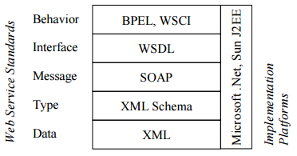
- Web Service Standards Stack

Mobile Proxy Design

Design Overview
Proposed proxy mobile design consists of three components, data, services, and applications, which are connected via two buses, the data bus and bus service. Illustration of design can be seen in Fig. 1.
Data bus Provides transparent access to the data source for web services. The data bus consists of two layers, ie cluster database layer and proxy layer. The cluster database layer consists of several database nodes that are equipped with a control cluster to ensure data synchronization. Meanwhile, the proxy layer consists of a proxy server that acts as a load balancer for database nodes. Load balancer is equipped with a healthy check to check the availability of each database node.
Similar with the data bus, the service bus handle web service invocation by the application. Web services that are representation of the rules, are packed as a bundle. Then the bundles are replicated, by composite application, from central repository to local repository. The bundles that are available in local repository will be installed and started dynamically by composite application. Moreover, installed bundles can also be stopped, removed, and updated easily.

Replication
Data and web services bundles are replicated from central storage to local storage as cache objects. Firstly, composite application replicate web services bundles from central repository to local repository. Each web services bundle then will replicate data that it is depend on, from central database into local cache storage.
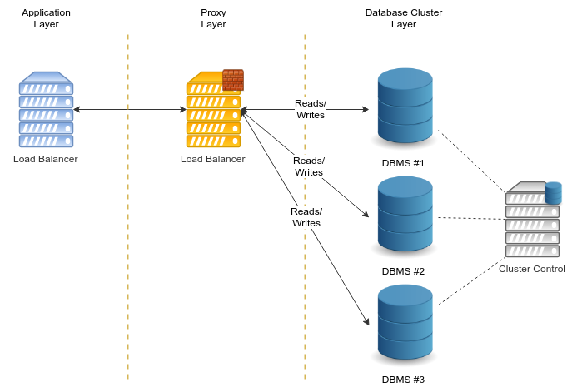
- Data bus Layers

Synchronization
Synchronization ensure the data and web service bundles are consistent between local and central repository. Web service bundle must implement versioning, so central server and proxy server must install bundles with same version to ensure the same logic is used. Composite application will periodically execute version check of the bundles, and replicate it when new versions are available in central repository.
Data synchronization is very depend on bundle, since each bundle require different data. Data will be synchronized in two way, from central database to local cache storage (e.g. master data) and from local cache storage to central storage (e.g. transaction data).

Routing
Routing plays important role in distributed system. It manages the network traffic and point requests to appropriate destination [23]. Local web services are act as proxy server that intermediate composite application, that act as client, and central server. Proxy server will decide whether to forward request to central server or reply it on behalf of central server.

Conclusion and Future Work
We proposed a mobile proxy design that allows the distribution web service dynamically as a bundle. It is intended to be suitable for current SOA-related standards technologies. It provides transparent resources (i.e. data and web service logics) access using combination of synchronization, replication, and routing mechanisms. Data integration is performed automatically, thus data can be viewed as a unity and does not need to be manually checked to ensure its integrity.
Our proposed design presented in this paper is preliminary result of our research. Our proposed design needs further research, especially in replication mechanism in mobile device, especially android environment, followed by realization for evaluation purpose. Well-designed mechanism will result easy configuration, increase availability, and improve system performance.

References
- [1] C. Gutwin, T. C. N. Graham, C. Wolfe, N. Wong, and B. de Alwis, “Gone but Not Forgotten: Designing for Disconnection in Synchronous Groupware,” in Proceedings of the 2010 ACM Conference on Computer Supported Cooperative Work, New York, NY, USA, 2010, pp. 179–188.
- [2] E. Gamma, Design patterns: elements of reusable object-oriented software. Pearson Education India, 1995.
- [3] H. Gani and C. Ryan, “Improving the Transparency of Proxy Injection in Java,” in Proceedings of the Thirty-Second Australasian Conference on Computer Science - Volume 91, Darlinghurst, Australia, Australia, 2009, pp. 55–64.
- [4] M. J. Wilson, “Get smart with proxies and RMI,” JavaWorld, 10-Nov-2000. [Online]. Available: http://www.javaworld.com/article/2076234/soa/get-smart-with-proxies-and-rmi.html. [Accessed: 12-Jun-2016].
- [5] P. Pratikakis, J. Spacco, and M. Hicks, “Transparent Proxies for Java Futures,” in Proceedings of the 19th Annual ACM SIGPLAN Conference on Object-oriented Programming, Systems, Languages, and Applications, New York, NY, USA, 2004, pp. 206–223.
- [6] “Fusion Middleware Understanding Oracle WebLogic Server.” [Online]. Available: https://docs.oracle.com/cd/E24329_01/web.1211/e24446/ejbs.htm#INTRO255. [Accessed: 12-Jun-2016].
- [7] O. Holder, I. Ben-Shaul, and H. Gazit, “System support for dynamic layout of distributed applications,” in Distributed Computing Systems, 1999. Proceedings. 19th IEEE International Conference on, 1999, pp. 403–411.
- [8] M. Philippsen and M. Zenger, “JavaParty - Transparent Remote Objects in Java,” Concurr. Pract. Exp., vol. 9, no. 11, pp. 1225–1242, 1997.
- [9] H. K. S. Rubinsztejn, M. Endler, and N. de L. R. Rodriguez, A Framework for Building Customized Adaptation Proxies for Mobile Computing. Citeseer, 2005.
- [10] C. Ryan and C. Westhorpe, “Application adaptation through transparent and portable object mobility in java,” in On the Move to Meaningful Internet Systems 2004: CoopIS, DOA, and ODBASE, Springer, 2004, pp. 1262–1284.
- [11] M. Tatsubori, T. Sasaki, S. Chiba, and K. Itano, “A Bytecode Translator for Distributed Execution of ‘Legacy’ Java Software,” in Proceedings of the 15th European Conference on Object-Oriented Programming, London, UK, UK, 2001, pp. 236–255.
- [12] E. Tilevich and Y. Smaragdakis, “J-Orchestra: Automatic Java Application Partitioning,” in Proceedings of the 16th European Conference on Object-Oriented Programming, London, UK, UK, 2002, pp. 178–204.
- [13] C. Cobârzan, “Dynamic Proxy-Cache Multiplication Inside LANs,” in Euro-Par 2005 Parallel Processing, J. C. Cunha and P. D. Medeiros, Eds. Springer Berlin Heidelberg, 2005, pp. 890–900.
- [14] L. Rizzo and L. Vicisano, “Replacement policies for a proxy cache,” IEEEACM Trans. Netw. ToN, vol. 8, no. 2, pp. 158–170, 2000.
- [15] A. Bestavros, R. L. Carter, M. E. Crovella, C. R. Cunha, A. Heddaya, and S. A. Mirdad, “Application-level document caching in the internet,” in Services in Distributed and Networked Environments, 1995., Second International Workshop on, 1995, pp. 166–173.
- [16] P. Cao and S. Irani, “Cost-Aware WWW Proxy Caching Algorithms.,” in Usenix symposium on internet technologies and systems, 1997, vol. 12, pp. 193–206.
- [17] M. F. Arlitt and C. L. Williamson, “Trace-driven simulation of document caching strategies for internet web servers,” Simulation, vol. 68, no. 1, pp. 23–33, 1997.
- [18] M. Abrams, C. R. Standridge, G. Abdulla, S. Williams, and E. A. Fox, “Caching proxies: Limitations and potentials,” 1995.
- [19] M. Busari and C. Williamson, “On the sensitivity of web proxy cache performance to workload characteristics,” in INFOCOM 2001. Twentieth Annual Joint Conference of the IEEE Computer and Communications Societies. Proceedings. IEEE, 2001, vol. 3, pp. 1225–1234.
- [20] A. Mahanti, D. Eager, and C. Williamson, “Temporal locality and its impact on Web proxy cache performance,” Perform. Eval., vol. 42, no. 2, pp. 187–203, 2000.
- [21] J. Shim, P. Scheuermann, and R. Vingralek, “Proxy cache algorithms: Design, implementation, and performance,” Knowl. Data Eng. IEEE Trans. On, vol. 11, no. 4, pp. 549–562, 1999.
- [22] B. D. Davison, “A survey of proxy cache evaluation techniques,” in Proceedings of the Fourth International Web Caching Workshop (WCW99), 1999, pp. 67–77.
- [23] Takdir and A. I. Kistijantoro, “Multi-layer SOA implementation pattern with service and data proxies for distributed data-intensive application system,” in 2014 International Conference on ICT For Smart Society (ICISS), 2014, pp. 37–41.
- [24] D. B. Terry and V. Ramasubramanian, “Caching XML Web Services for Mobility.,” ACM Queue, vol. 1, no. 1, pp. 70–78, 2003.
- [25] X. Liu, D. Yuan, and G. Zhang, The Design of Cloud Workflow Systems. Dordrecht: Springer, 2012.
- [26] M. Wieland, K. Gorlach, D. Schumm, and F. Leymann, “Towards reference passing in web service and workflow-based applications,” in Enterprise Distributed Object Computing Conference, 2009. EDOC’09. IEEE International, 2009, pp. 109–118.
- [27] C. Pautasso, “RESTful Web service composition with BPEL for REST,” Data Knowl. Eng., vol. 68, no. 9, pp. 851–866, 2009.
- [28] S. Weerawarana, F. Curbera, F. Leymann, T. Storey, and D. F. Ferguson, Web services platform architecture: SOAP, WSDL, WS-policy, WS-addressing, WS-BPEL, WS-reliable messaging and more. Prentice Hall PTR, 2005.
- [29] J. Pasley, “How BPEL and SOA Are Changing Web Services Development,” IEEE Internet Comput., vol. 9, no. 3, pp. 60–67, May 2005.

